CS 470 Module Four Assignment Two Guide

Part One: Creating an API Using API Gateway

- Navigate to the API Gateway in the AWS console. It is located under the Networking & Content Delivery section. You can also search for the gateway.
- Click the Create REST API button in the REST APIs box.

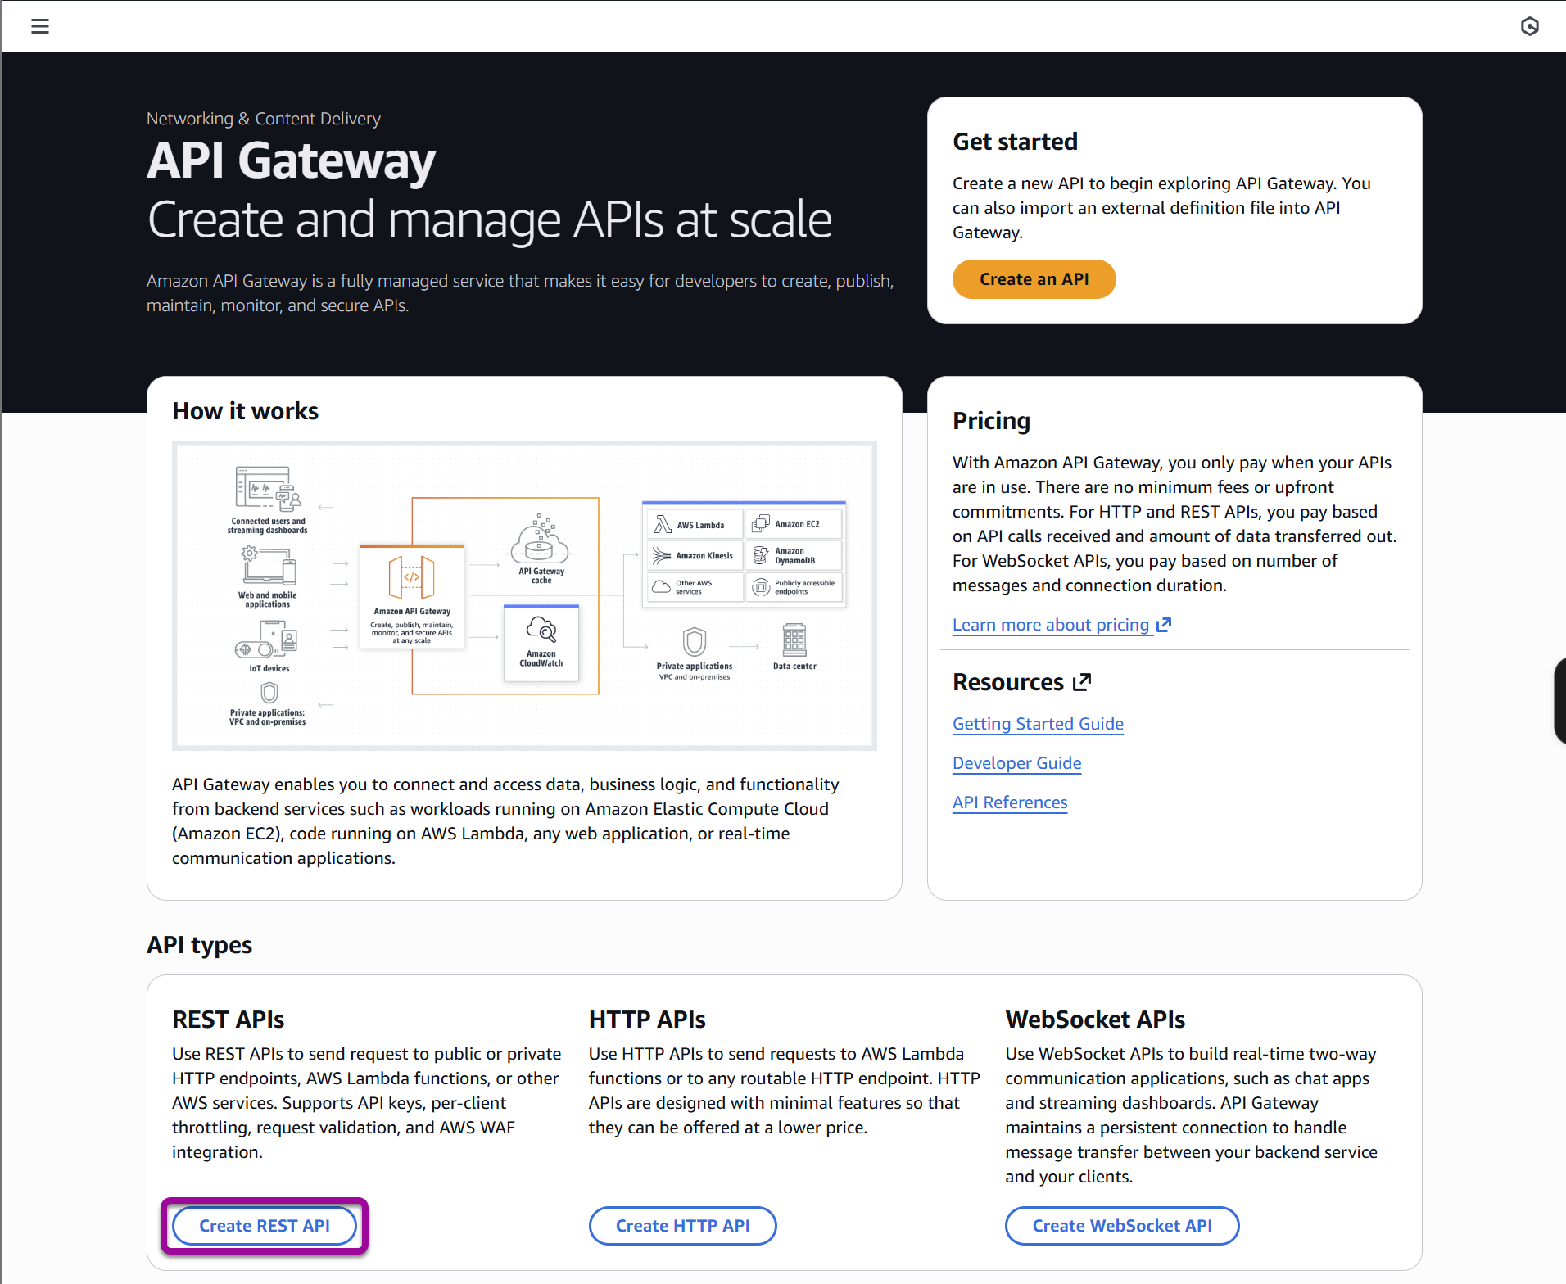

- Select New API in the API details section.
- Set the API name to “Echo” and give it the description “My Echo Service”.
- Leave the API endpoint type as Regional.
- Set the Security policy to the latest recommended SecurityPolicy_TLS13 (not using FIPS).
- Click the orange Create API button in the lower-right corner.

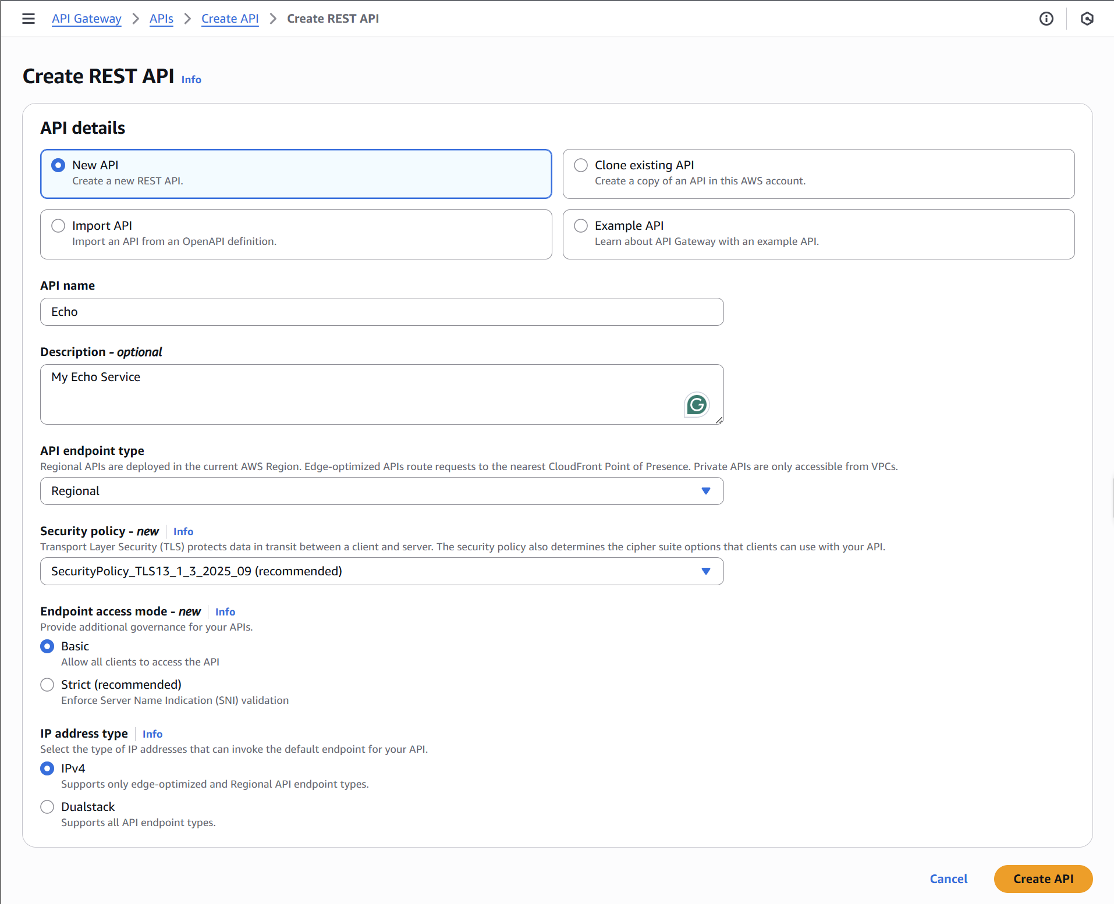

- You will now see a mostly blank screen titled “/”.

Believe it or not, you have now created an API. The API will not do anything yet, but that is for the next part.

Part Two: Adding a Method to Your API

- Click the Create method button toward the right of your screen.

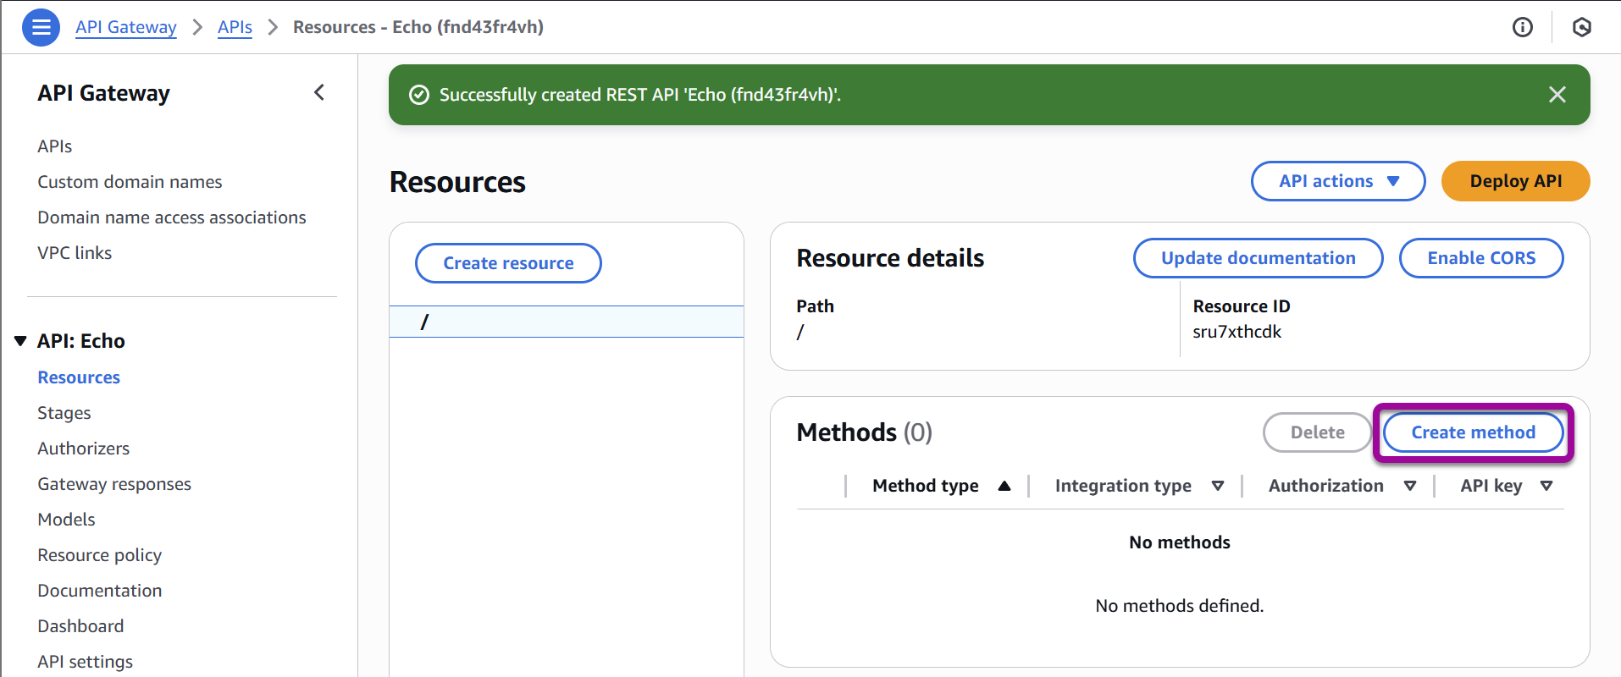

- On the Create method page, in the Method type menu select GET to handle HTTP GET requests.
  - This menu is where you will select the REST methods to process for your API. The other options are direct mappings to HTTP methods. However, ANY is used to match all of the requests. ANY will match any request not explicitly handled by another method definition.

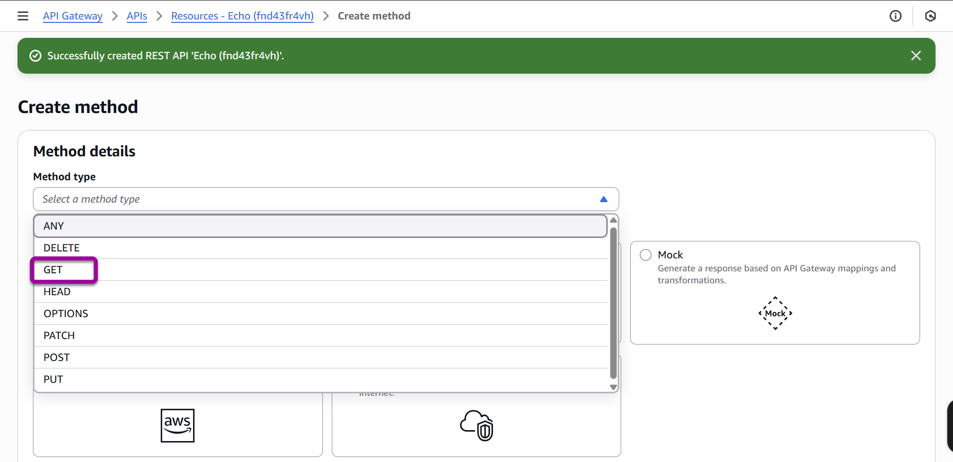

- Now, you must set up your method. Make certain the integration type is Lambda Function.
- Make certain the Lambda proxy integration slider is set to on/True, leave the Response transfer mode to Buffered.
- Leave the Lambda function region as us-east-1.
- Type “EchoFunction” in the Lambda function box. AWS will suggest it for you as you type.
- Leave the default Integration timeout to 29000.
- Click the orange Create method button in the lower-right corner.

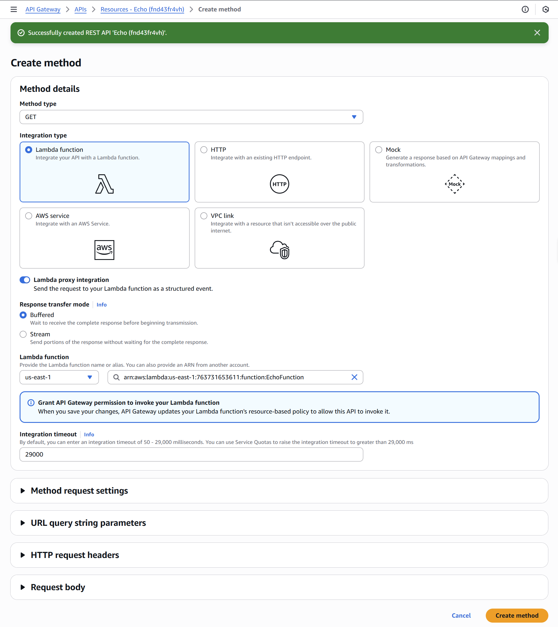

- You will now see the fully populated Method Execution page.

Congratulations! You have wired up your API to your Lambda.

Part Three: Testing Your API to Lambda Method

- Click the Test link in the bottom-right section.
- Click the orange Test button.
- The right side of the page will show you the Response Body, Response Headers, and API Gateway Logs.
- It worked! But not really. You didn’t pass it a name to reply with, so it says, “Hello unknown”. Let’s fix that.

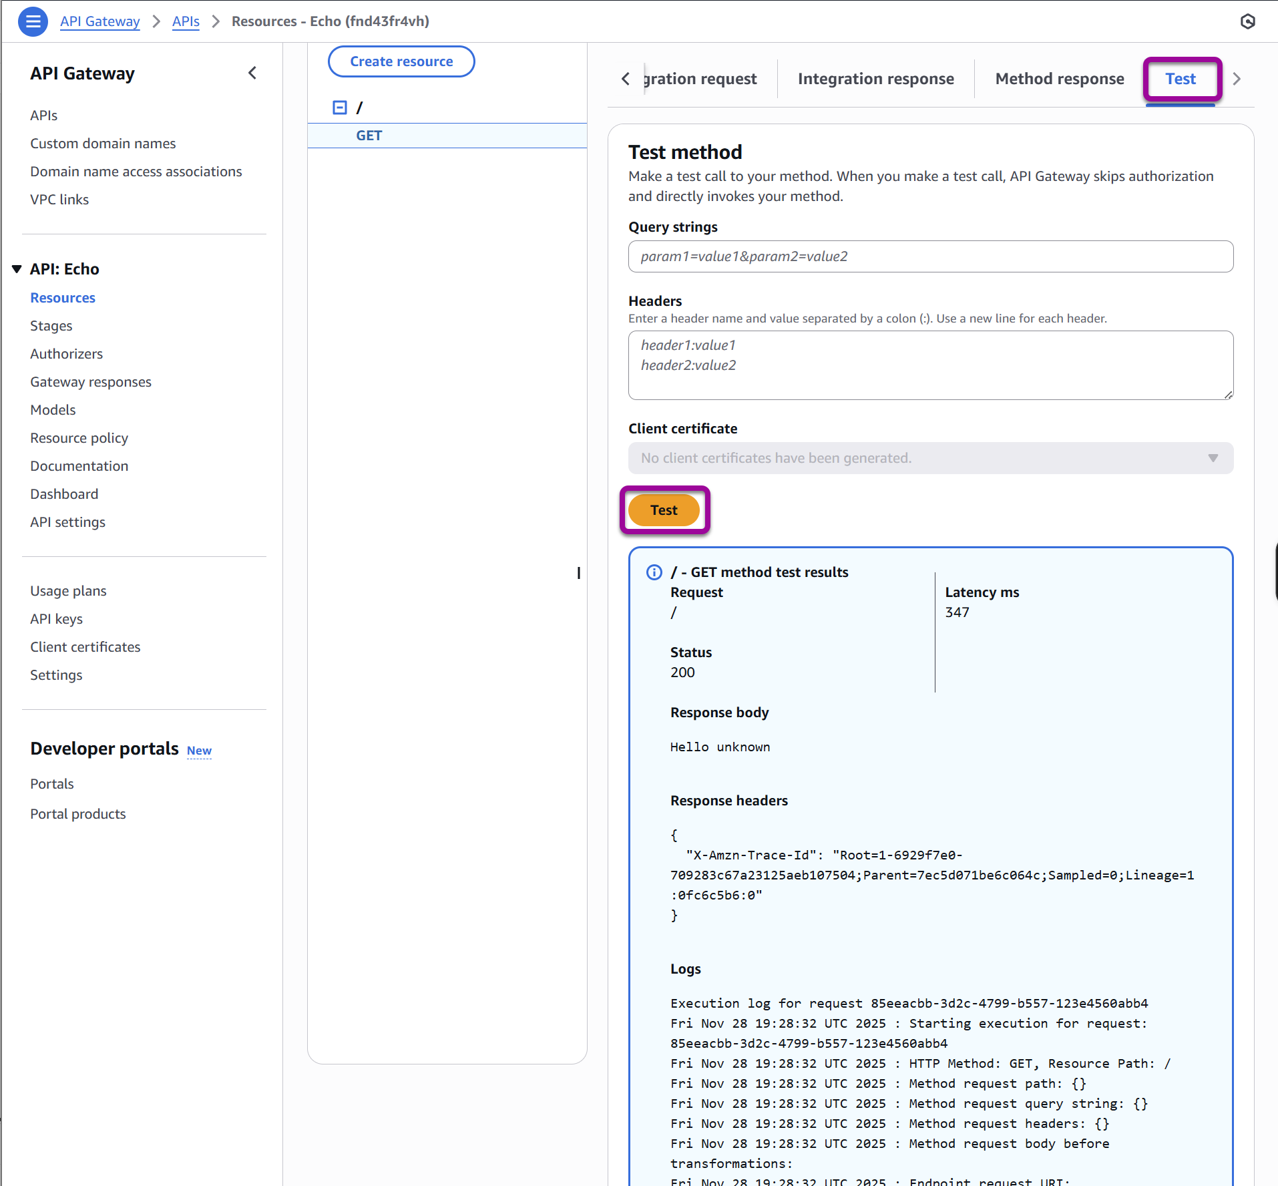

- Scroll to the top of the page. In the Method Execution, select the Method Request box by clicking its name.
- Click the Edit button in the top-right corner of the Method request settings.
- Expand the URL Query String Parameters section.
- Click Add query string.
- Enter “name” (without quotes) in the input box and click the Save button.
- Select the Test link in the upper-right side of the lower section as before.
- You can now enter a query string for your test. Type “name=Nancy” (without quotes).
- Click the Test button.

Note: if your response is still “Hello unknown” go back to check the settings for the Integration request Lamba proxy integration settings to confirm the value is set to True, if it is false, edit the setting and test again.

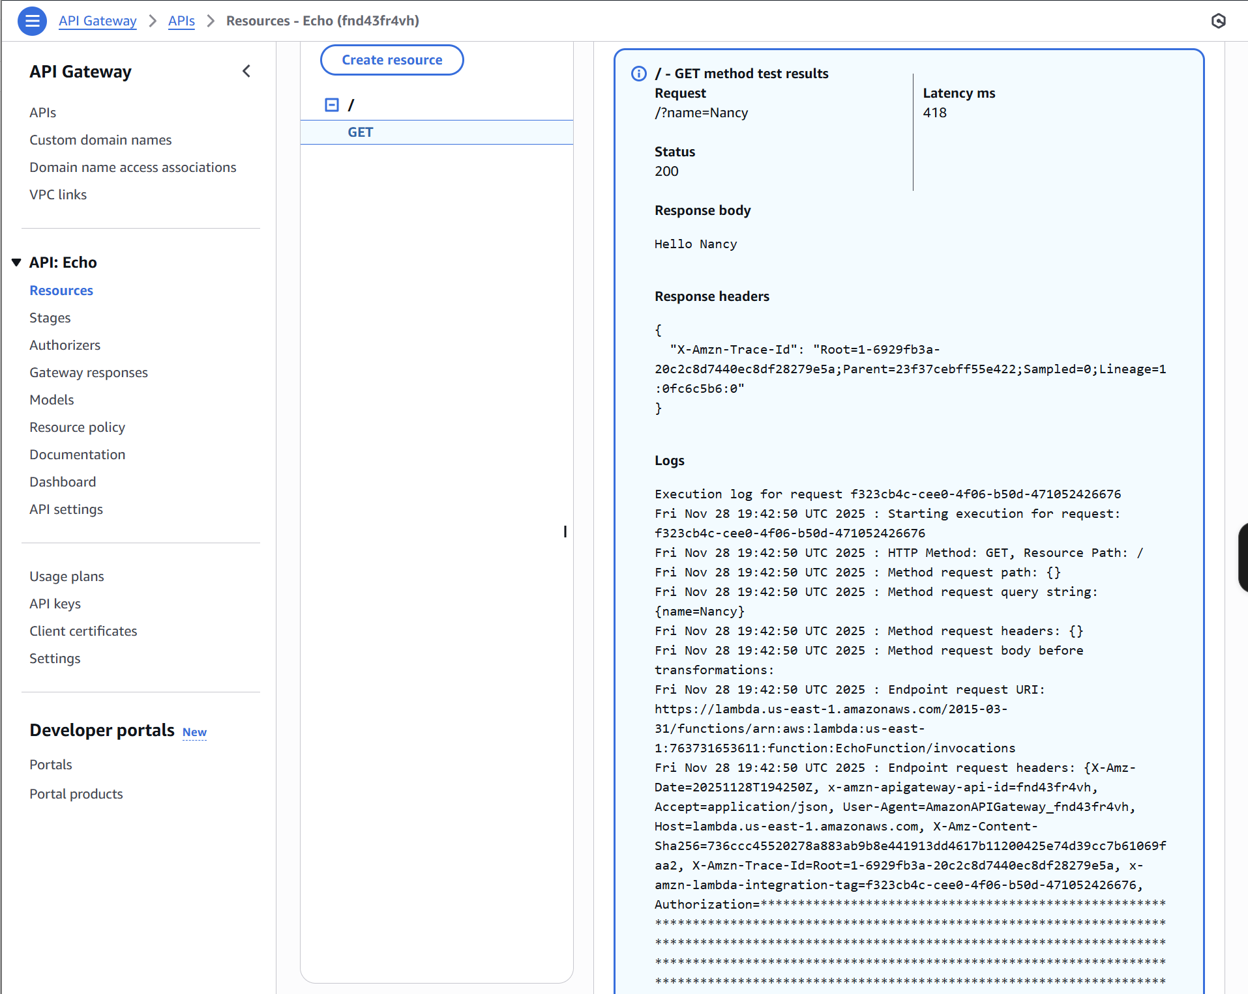

Success! You have tested your API with a parameter calling your Lambda.

Part Four: Deploying Your API

- You have a shiny new API. But it is not yet callable from outside of AWS. You need to deploy it to allow that. To deploy your API, select the orange Deploy API button at the top right of the page.
- Select *New stage* in the Stage drop-down menu.
- Type “API” as your Stage name.
- Type “Where I put my APIs” for the Deployment description.

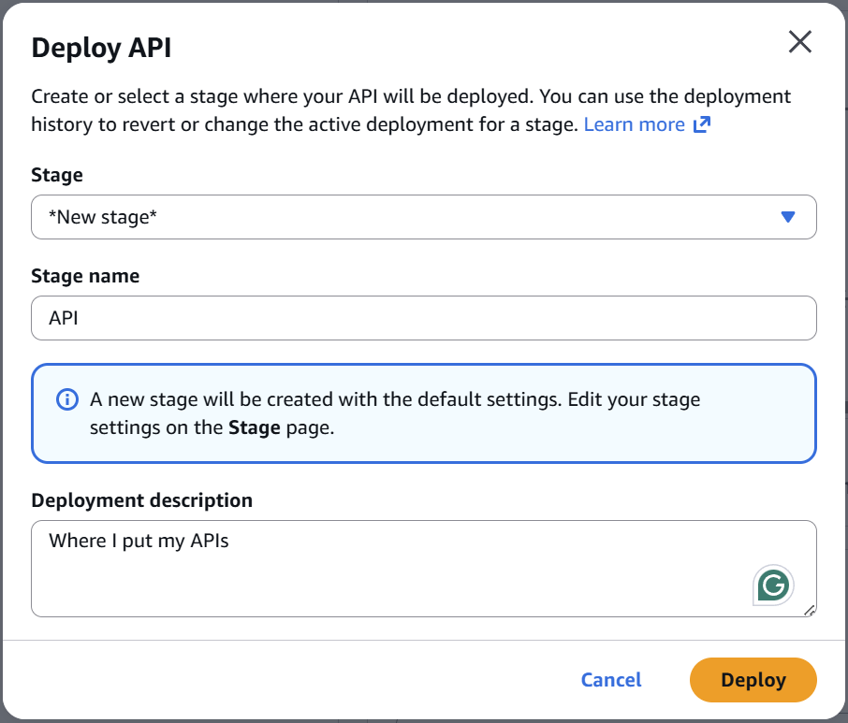

- Click the Deploy button.
- A few seconds later, your API will be deployed, and you will have your shiny new URL.

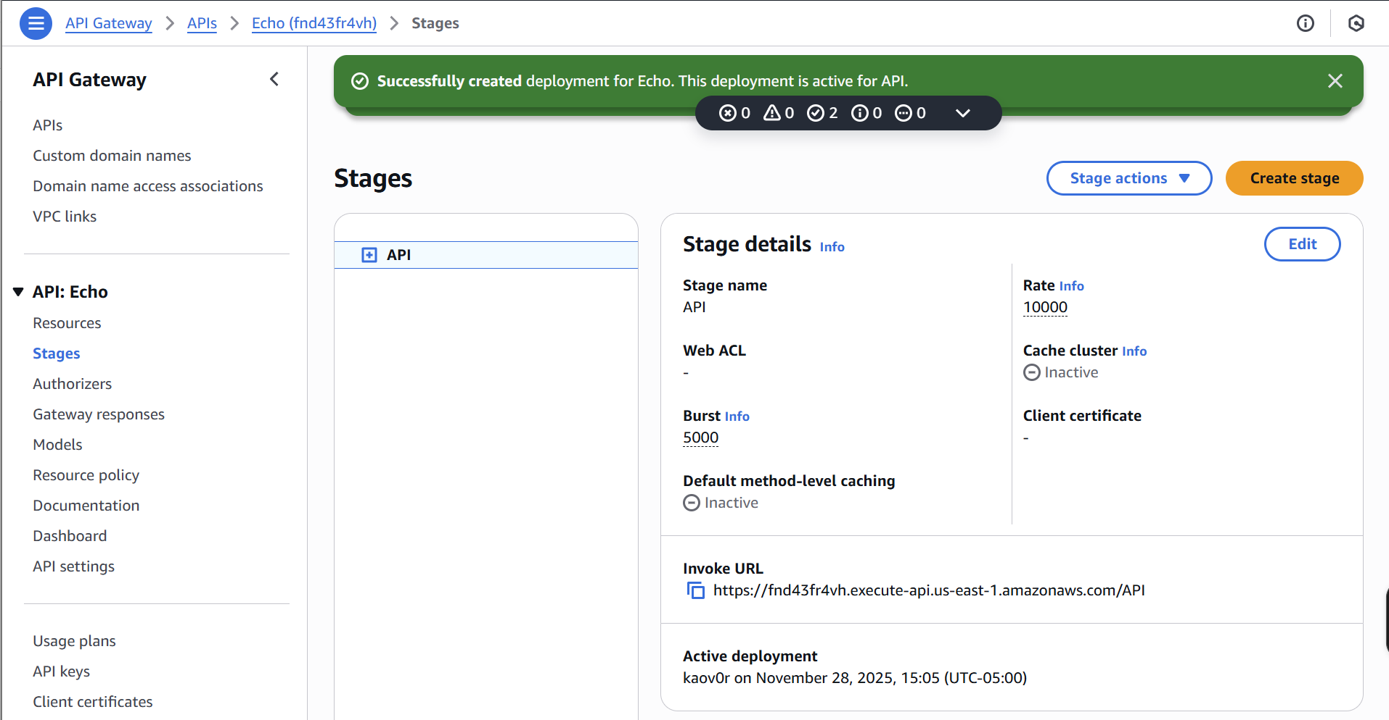

- If you navigate to the URL, it will work in your browser. Make certain you are using a browser other than Firefox when you try this.

Note that you may need to wait a minute or two before running the URL. If you get a response message of Forbidden, give it another minute then refresh the browser again until you see “Hello unknown”.

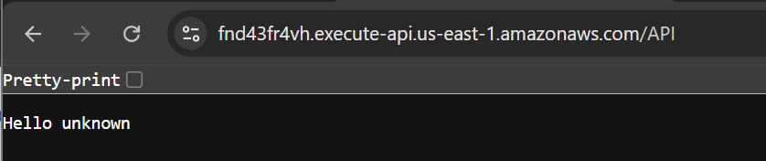

- You can put in a query parameter to make the message more personalized.

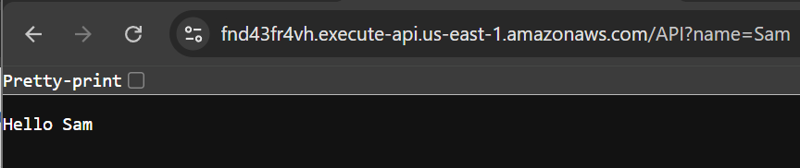

That’s it. You have created a Lambda, tested it, created an API, connected it to your Lambda, and tested it again. Finally, you deployed your API. Your project will build upon these functions to connect your Angular application to new Lambdas that you will write, which will connect to the database you will learn about in the next module.

Great work!

